Domain : Student Management
Front-end: Java (JDK 1.7 or use Java IDE)
Back-end : MS Access 2007

Before you compile the project you have to set the ODBC connection then only it will work properly
Let us see How to set ODBC connection (MS Access)

- Click Start button +Click Settings

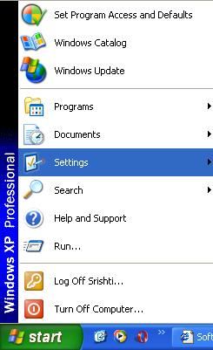

- Click Control Panel

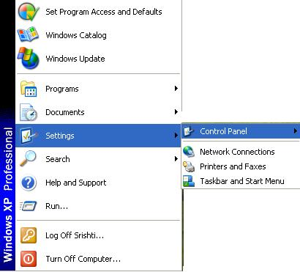

- Select Administrative tools + Click data Sources (ODBC)
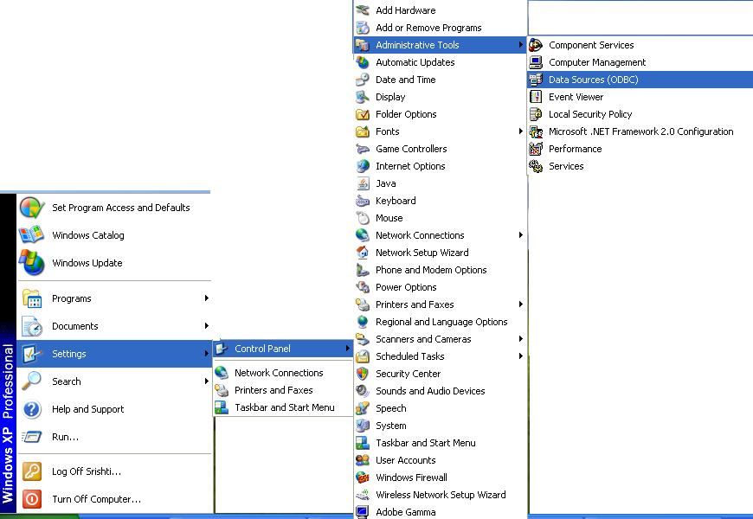

4. Then you get ‘ODBC Data Source Administrator’ window (shown below) +Click Add Button

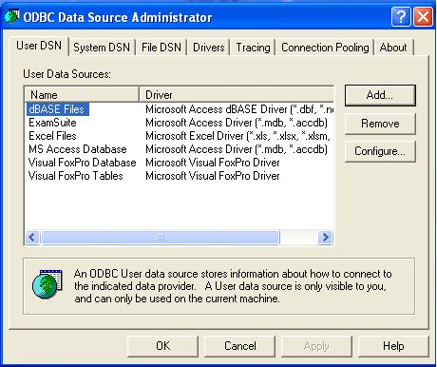

5. Create New Data Source (shown below) +select Microsoft Access Driver (*.mdb,*.accdb) + press Finish button
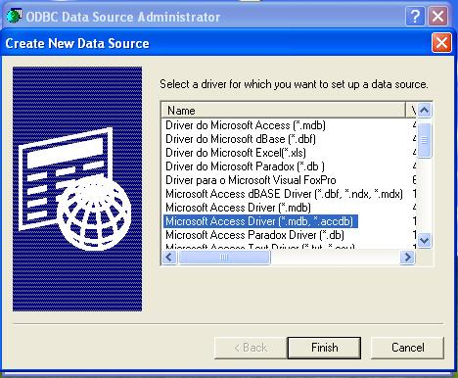
6. ODBC Microsoft Access Set up (shown below) + gives Data Source Name
+select Database (Press select button) +select your database (shown below) + Press Ok button
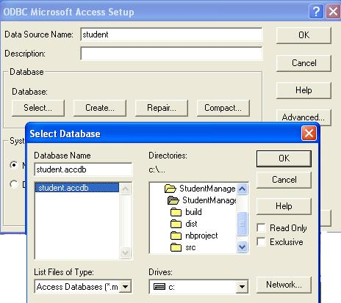
7. Before you close the window make sure that your DSN name is correct or not (shown below) +Press Ok button
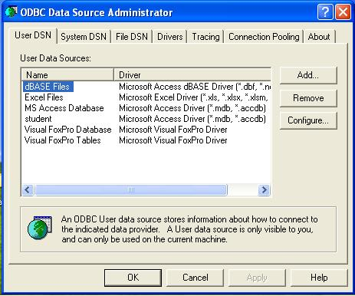
Now you got the DSN name (student) this is the way for connecting ODBC, if you have any doubt please mail us.

